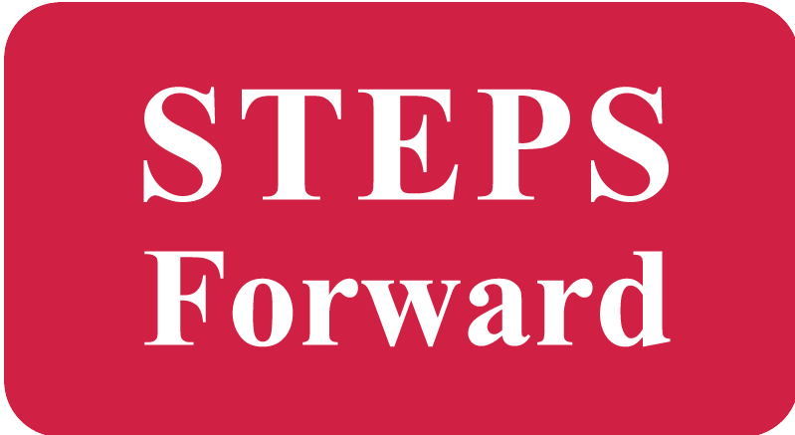
Supporting students with developmental diverse abilities t study, work and meet new people at their local university. University.

STEPS Forward has spots at UBC Okanagan in September 2015 for students with developmental disabilities!

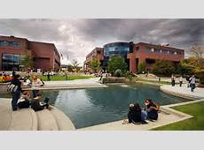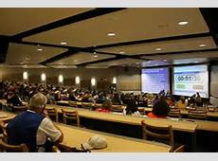

Students study courses of interest, join clubs and campus activites and try different jobs that help to develop a career.

STEPS Forward staff help to:
- Figure out courses to study
- Modify course work
- Facilitate relationships with professors
- Meet new people
- Find fun things to do on campus
- Find student employment

Eligibility is NOT based on academic qualifications or level of ability. Applicants must be CLBC eligible

For more information about STEPS Forward at UBC Okanagan contact Tiffany Thesen-Yee:

250-807-8555 | tiffany@steps-forward.org
www.STEPS-forward.org

